Criterion 6 | Facilities And Technical Supports | 100

6.1 Availability of Adequate, Well-Equipped Classrooms to meet the Curriculum Requirements: (10)
Adequate number of classrooms and laboratories are available for conduction of lectures and practical in department. The classrooms are exclusively used by students of computer engineering department for theory and tutorials. Department consists of three class rooms for each year exclusively and one tutorial room. Department also consisting of Smart board, Android Television set and Audio Speaker System. This facility is shared among third, second and first year students for Expert lectures. Drawing Hall is shared with other department for related academic work.
Sr. No | Classroom No. | Board | Duel Bench, Seating Capacity | Tube-light,Fan | Area Sq. m | Remark
1 | Class Room - 108  First Year Class Room ( Main Building ) | Yes | Duel Bench (60+ nos.) | Yes |  | As Per AICTE Norms
2 | Class Room - 2  Second Year Class Room (Computer Engg. Building ) | Yes | Duel Bench (60+ nos.) | Yes |  | As Per AICTE Norms
3 | Class Room – 3 Third Year Class Room (Computer Engg. Building ) | Yes | Duel Bench (60+ nos.) | Yes |  | As Per AICTE Norms
4 | Class Room – 201  Drawing Hall ( Main Building ) | Yes | Wooden Drawing desks with stools (70+ nos.) | Yes |  | As Per AICTE Norms
5 | Tutorial Room ( Main Building ) | Yes | Duel Bench (15+ nos.) | Yes |  | As Per AICTE Norms

Table No. 6.1.1 Details of class rooms facilities available
All above rooms are airy, spacious, acoustically designed, with separate exit and entrance. The decent flooring and furniture provide good ambience for study.
6.2 Availability of adequate and well-equipped Workshops, Laboratories and Technical manpower to meet the curriculum requirements (40)
- Adequacy (10)
The Computer Engineering Department has sufficient and well-equipped laboratories to meet all curriculum requirements. There are seven laboratories covering key course such as Basic Programming Laboratory, Android App Development Laboratory, Software Engineering Laboratory, Web Development Laboratory, Advanced Programming Laboratory, Unix/OS Laboratory, Hardware and Networking Laboratory. Each Laboratory provides sufficient seating arrangement and computing facility to support the student strength, with almost 1:1 student to computer ratio. All laboratories are utilized by all students in computer engineering department on weekdays from 10.00 AM to 06.00 PM. Utilization includes Practical sessions, Project works, MOOCs, Self-Learning Activities like Infosys Spring board courses, Seminars Etc. These laboratories are maintained by qualified technical staff. Department also has five labs which are used on shared basis with Science and humanities, Electronics and telecommunication Engineering and Electrical Engineering Department. Details are as shown in below table.
Sr. No | Name of Laboratory | Name of Important Equipment/Facility | No. of Students Per Batch | Remark
1 | Basic Programming Laboratory | 21 Desktop PCs with Cushioned Chairs and CCTV cameras | 20 Students | 1- Smart Board, 1- T,V Set, 1- AC, Epson MFP Printer
2 | Android App Development Laboratory | 21 Desktop PCs with Cushioned Chairs and CCTV cameras | 20 Students | 1- Smart Board, 1- AC, ALTOS Server
3 | Software Engineering Laboratory | 24 Desktop PCs with Cushioned Chairs and CCTV cameras | 20 Students | 1- AC Facility, 1- Wheel Chair
4 | Web Development Laboratory | 21 Desktop PCs with Cushioned Chairs and CCTV cameras | 20 Students | 1- AC, 1- Wheel Chair
5 | Advanced Programming Laboratory | 30 Desktop PCs with Cushioned Chairs and CCTV cameras | 20 Students | 1- Smart Board, 1- T,V Set, 1- AC, Epson MFP Printer
6 | Unix/OS Laboratory | 30 Desktop PCs with Cushioned Chairs and CCTV cameras | 20 Students | 1- AC,1-Cup-board,1-White board
7 | Hardware and Networking Laboratory | Desktop PCs with Chairs and Hardware Kits | 20 Students
8 | Physics Laboratory | Joules calorimeter, Searle’s apparatus, Photocell, Vernier calliper, Micro meter screw gauge | 20 Students | Shared Usage
9 | Chemistry Laboratory | Electric oven, Muffle furnace, PH meter. | 20 Students | Shared Usage
10 | Language Laboratory | 24 Desktop PCs with Headset | 20 Students | Shared Usage
11 | Basic Electrical Engineering  Laboratory |  | 20 Students | Shared Usage
12 | Digital Electronics  Laboratory |  | 20 Students | Shared Usage
Table 6.2.1 Information of available laboratories
- Quality of Labs/workshop (20)

All computer laboratories are equipped with the latest desktop configurations. Each Laboratory has a minimum of 20 computers, except for the hardware Laboratory, which provides almost one computer per student during practical sessions. Laboratory from serial number from 1 to 6 has Air-Conditioning facility in cubicles arrangement. These laboratories are having Wi-Fi Connections, Smart Boards, and Television with Audio Set, Bag Storage Rack, Cup-board and CCTV camera monitoring facility inside laboratory and outside passage.
Computer engineering department is following below mentioned policy for maintaining the quality of laboratory.
- DSRs are maintained in the computer department as per norms of government.
- Routine maintenance activity is performed by laboratory assistant named Mr. Raju R. Jadhav and Mr. Suhas S Gund. Maintenance register is maintained by them for record keeping purpose.
- Safety instructions, list of experiments, Course outcomes (COs), Lab-wise Timetable and standard operating procedures (SOPs) are displayed in all laboratories
- Power backup is available for all PCs, CCTV cameras and Wi-Fi / Internet facility.
Below mentioned table gives quick overlook of the respective labs and available facilities in laboratory.
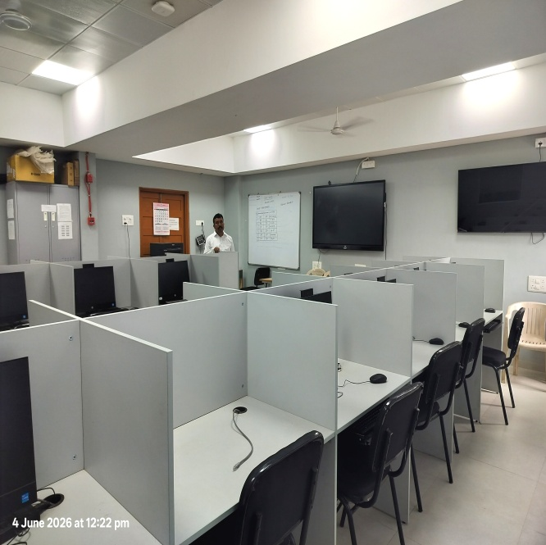 | 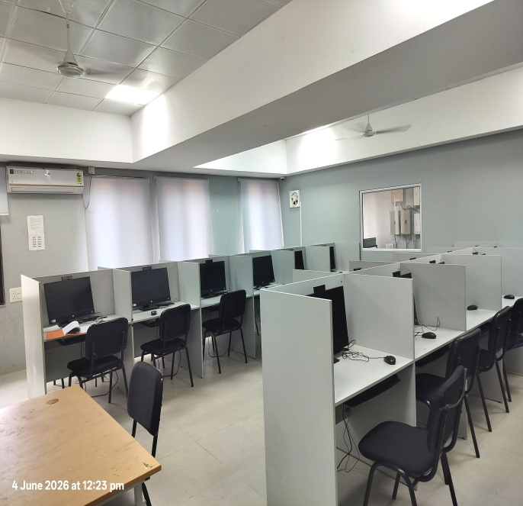
Basic Programming Laboratory  - HP Desktop PC – 21 Nos.  - Air-Conditioning System  - Interactive Smart Board + Television System  - ALTOS Server System + Epson MFP Printer  - 100 Mbps Internet Connectivity  - Modular Furniture with Cushioned Chairs | - Biometric Attendance System for Students  - Power Backup, Audio-PA System  - CCTV Surveillance System  - Fire Alarm System, Fire Extinguisher  - Bag Rack, Wi-Fi, Wheel-Chair, Frisking System  - Secure Access to Doors for Entry  - White-Board, Lights, Fans, Cup Board.
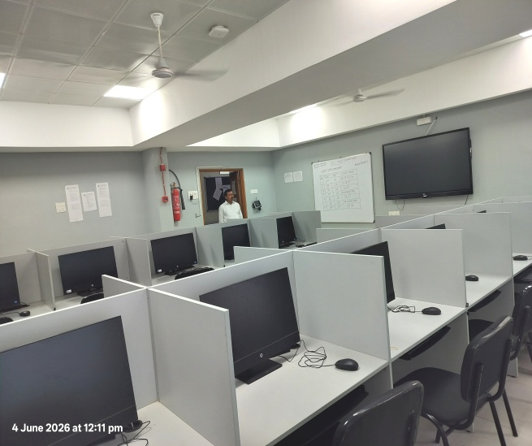 | 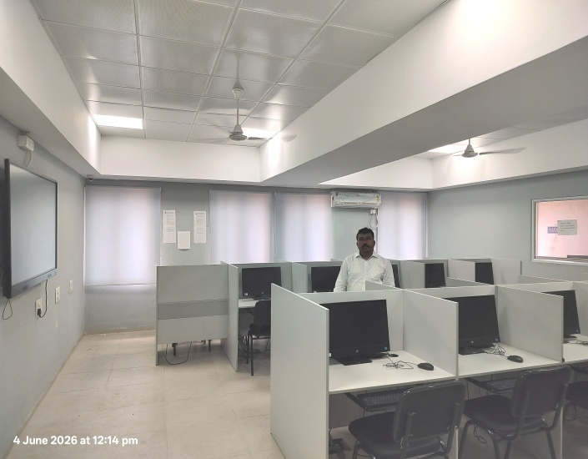
Android App Development Laboratory  - HP Desktop PC – 21 Nos.  - Air-Conditioning System  - Interactive Smart Board  - ALTOS Server System  - 100 Mbps Internet Connectivity  - Modular Furniture with Cushioned Chairs | - Biometric Attendance System for Students  - Power Backup, Audio-PA System  - CCTV Surveillance System  - Fire Alarm System, Fire Extinguisher  - Bag Rack, Wi-Fi, Wheel-Chair, Frisking System  - Secure Access to Doors for Entry  - White-Board, Lights, Fans etc.
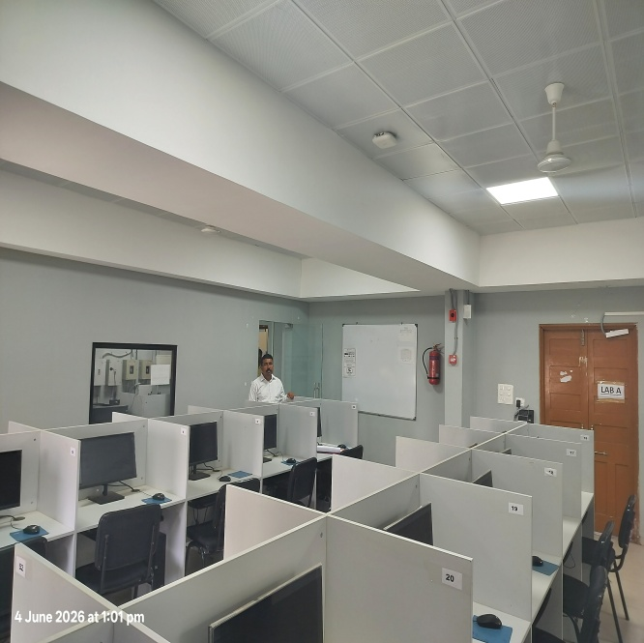 | 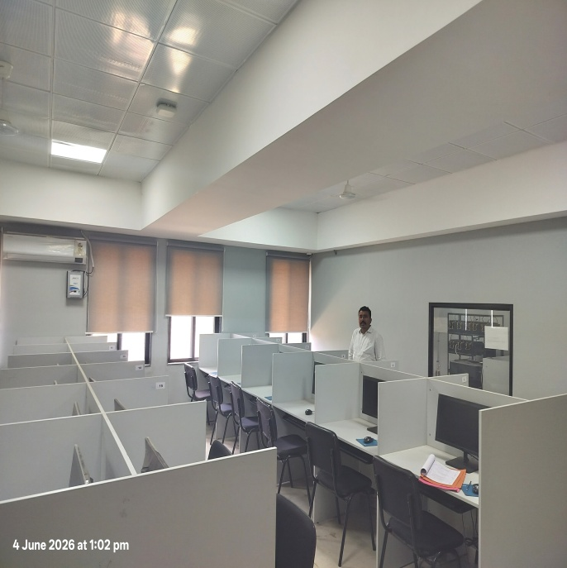
Software Engineering Laboratory  - Acer Desktop PC – 24 Nos.  - Air-Conditioning System with stabilizers  - ALTOS Server System + Epson MFP Printer  - 100 Mbps Internet Connectivity  - Modular Furniture with Cushioned Chairs | - Biometric Attendance System for Students  - Power Backup, Audio-PA System  - CCTV Surveillance System  - Fire Alarm System, Fire Extinguisher  - Wi-Fi, Frisking System  - Secure Access to Doors for Entry  - White Board, Lights, Fans etc.
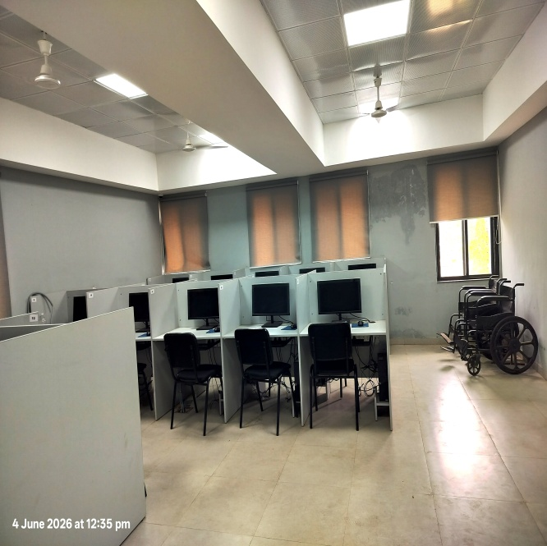 | 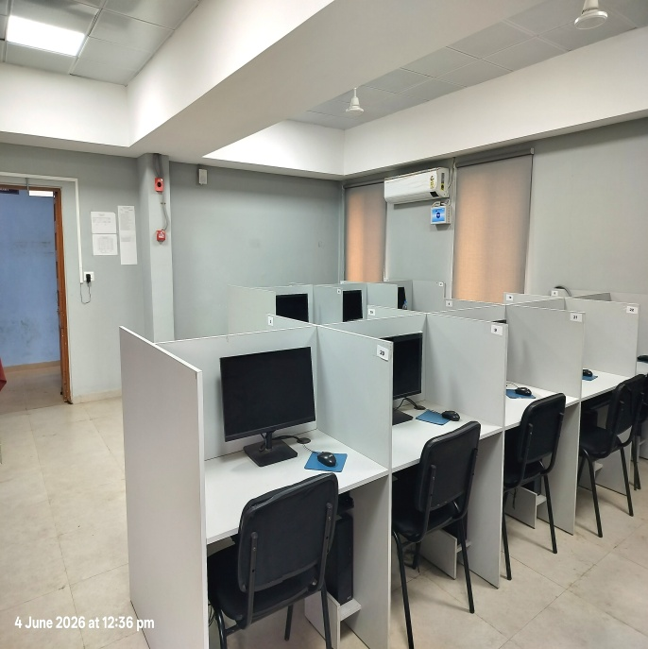
Web Development Laboratory  - Acer Desktop PC – 21 Nos.  - Air-Conditioning System with stabilizers  - 100 Mbps Internet Connectivity  - Intercom Phone System  - Modular Furniture with Cushioned Chairs | - Biometric Attendance System for Students  - Power Backup, Audio-PA System  - CCTV Surveillance System  - Fire Alarm System, Fire Extinguisher  - Wi-Fi, Frisking System  - Secure Access to Doors for Entry  - White Board, Lights, Fans etc.
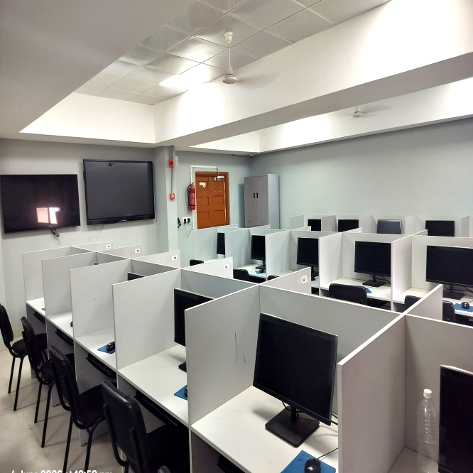 | 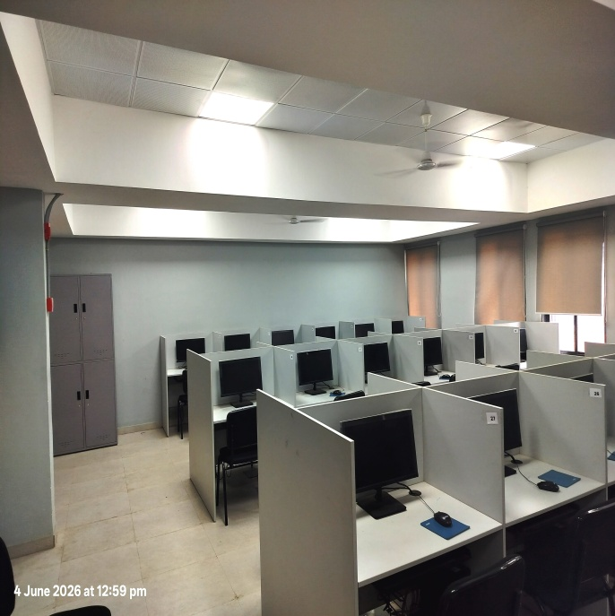
Advanced Programming Laboratory  - Acer Desktop PC – 30 Nos.  - Interactive Smart Board + Television System  - White Board and Cupboard  - 100 Mbps Internet Connectivity  - Modular Furniture with Cushioned Chairs | - Biometric Attendance System for Students  - Power Backup, Audio-PA System  - CCTV Surveillance System  - Fire Alarm System, Fire Extinguisher  - Wi-Fi, Frisking System  - Secure Access to Doors for Entry  - Lights, Fans etc.
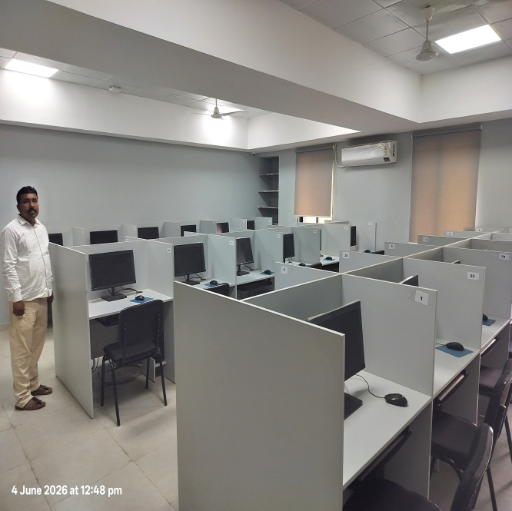 | 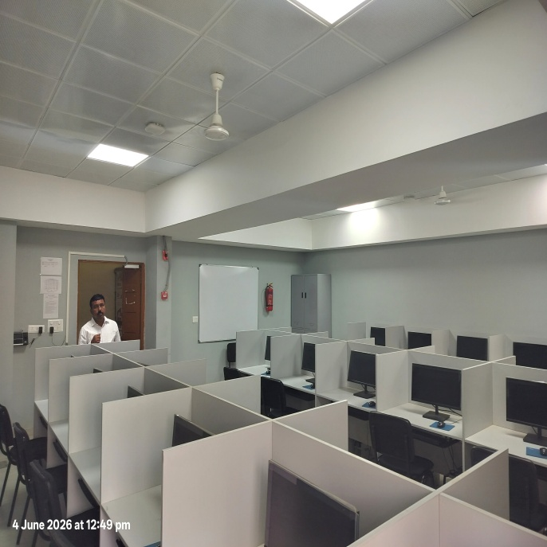
Unix/OS Laboratory  - Acer Desktop PC – 30 Nos.  - White Board and Cupboard  - 100 Mbps Internet Connectivity  - Modular Furniture with Cushioned Chairs  - Intercom Phone System | - Biometric Attendance System for Students  - Power Backup, Audio-PA System  - CCTV Surveillance System  - Fire Alarm System, Fire Extinguisher  - Secure Access to Doors for Entry  - Lights, Fans etc.
Photo-1 | Photo-2
Hardware and Networking Laboratory
Table 6.2.2 Photos of available laboratories
All above laboratories are having First-Aid kits, Purified Drinking Water Facility. Computer Engineering department also have separate facility of washrooms for faculty, girls and boys as well as Divyangjan (Persons with Disabilities) persons.
- Technical Manpower support –Eligible and Adequate (10)
The computer engineering department maintains adequate technical support staff to ensure the smooth conduct of laboratory sessions, maintenance of hardware / software, and assistance to faculty during practical hours. The technical staff is selected based on their technical proficiency in relevant domains. Also for each laboratory, Head of Department has appointed a Lecturer as Laboratory In-Charge. Following table gives overview of this.
Sr. No. | Name of the Laboratory | Name of the Lab In-charge | Designation | Name of the technical staff | Designation | Qualification
1 | Basic Programming Laboratory | Shri A D Ambure | Lecturer in Computer Engineering | Raju Ramrao Jadhav | Technical Laboratory Assistant | B.Sc. (ITI)
2 | Android App Developmant Laboratory | Shri A B Gaikwad | Lecturer in Computer Engineering | Raju Ramrao Jadhav | Technical Laboratory Assistant | B.Sc. (ITI)
3 | Software Engineering Laboratory | Shri N V Bhalerao | Lecturer in Computer Engineering | Raju Ramrao Jadhav | Technical Laboratory Assistant | B.Sc. (ITI)
4 | Web Development Laboratory | Shri B R Chauhan | Lecturer in Computer Engineering | Raju Ramrao Jadhav | Technical Laboratory Assistant | B.Sc. (ITI)
5 | Advanced Programming Laboratory | Smt. S P Kadam | Lecturer in Computer Engineering | Suhas S. Gund | Technical Laboratory Assistant | Diploma in IT
6 | Unix/OS Laboratory | Shri P J Bansode | Lecturer in Computer Engineering | Suhas S. Gund | Technical Laboratory Assistant | Diploma in IT
7 | Hardware and Networking Laboratory | Shri N V Bhalerao | Lecturer in Computer Engineering | Suhas S. Gund | Technical Laboratory Assistant | Diploma in IT

Additional facilities created for improving the quality of learning experience in laboratories (20)

Facilities (10)

Effective Utilization (05)

Relevance to POs/PSOs (05)

S.N | Facility Name | Details | Reason(s) for creating facility | Utilization | Area in which students are exposed to have enhanced learning | Relevant to PO/PSO
1 | Online Examination | Facility for Conduct of MSBTE Online Examination is available. All In One Computers with Web-Cameras, High-Speed Internet, AC, CCTV Cameras, WiFi Facilities are provided. | Used for MSBTE Examination as well as Baseline Test conducted by MSBTE each semester. | Facility is utilized by Compuer Engg Students as well all students of other Programs. Exam/Test are conducted Each Semester | This facility is maintained well and hence it helps students to boost their handling of computer/digital devices as well as confidence level in examination | PO1 to PO7 and PSO1, PSO2
2 | Departmental Library
3 | Seminar Hall (MB-CAD-CAM Lab.)
4 | Auditorium Facility (Main Building 2nd Floor )
5 | Digital Library | NDL access, e-books, and MOOCs, NPTEL | To supplement technical curriculum with current industry trends | Information Collection for Self-Learning Activity, Development of projects and seminar preparation | Lifelong learning and advanced technical research | PO 1, PO 2, PO 7, PSO 1
6 | Canteen | Hygienic food court | To provide accessible nutrition to support daily energy | Daily usage during breaks | Professional ethics and social interaction | PO 5
7 | Students Cooperative Store | Essential stationery like File/Folder, Notebooks, Laboratory Manual, Tutorial Pages, Xerox Facility Etc | To provide affordable access to learning resources | Purchasing lab manuals, drawing tools, and stationery | Resource management | PO 6
8 | Smart Board/Screen Facility | Interactive display | Enable active, visual learning | Classroom/Seminar hall Presentation, Demonstration of Project | Pedagogical interaction & visualization | PO 4, PO 7
9 | Water Filters | R.O. purification points | To ensure a healthy learning environment | Access during lab sessions and extracurricular | Health, safety, and sustainable practices | PO 5
10 | Wi-Fi in building | Campus-wide high-speed internet | To enable students to learn new emerging technologies (AI, Cloud, IoT) | Accessing Gmail, NPTEL, e-learning platforms, and blogs writing | Digital literacy and network administration | PO 1, PO 4, PSO 2
11 | CCTV Cameras | Integrated surveillance system | To ensure lab security and equipment protection | Monitoring sensitive lab environments | Security awareness and professional discipline | PO 5, PO 6
12 | TV Screen | Large display monitor | Display technical tutorials | Digital Video/Audio demonstration, Blended Learning approach | Multimedia-based learning | PO 4, PO 7

  - Laboratories: Maintenance and overall ambiance (10)

1. Maintenance Strategy
The Computer Engineering department follows a systematic approach to ensure that all laboratory equipment remains functional and the environment is optimized for learning.
- Preventive Maintenance: Hardware, networking equipment, and software are checked periodically by the Laboratory Assistants (Shri. Raju Ramrao Jadhav and Shri. Suhas S. Gund) to ensure uninterrupted practical sessions.
- Corrective Maintenance: Upon reporting a malfunction, the technical staff initiates immediate repairs or coordinates with external vendors if the equipment is under warranty or requires specialized service.
- Role of Support Staff: A Peon is assigned to each laboratory to ensure daily cleanliness, proper arrangement of furniture, and maintenance of a dust-free environment.

2. Staff and Student Coordination
The department operates through a collaborative hierarchy to maintain lab standards:
- Technical Staff Role: Our two Lab Assistants are responsible for the technical upkeep of software configurations, server management, and network troubleshooting.
- Student Responsibility: Students are encouraged to maintain a professional environment by adhering to the "Do’s and Don’ts" displayed in each lab, handling equipment with care, and maintaining silence to foster an academic atmosphere.
- Lab In-Charge Oversight: The Lab In-charge supervises the entire maintenance cycle and ensures that the laboratories are working fine all the time.

3. Overall Ambiance and Facilities
To provide an enhanced learning experience, the laboratory environment is augmented by several campus and department-level facilities:
- Technological Integration: Each lab is equipped with a Smart Board and TV Screen to facilitate interactive demonstrations of coding, simulation, and hardware architecture, directly supporting active learning.
- Security and Safety: CCTV cameras are installed inside and outside the labs to ensure equipment safety and monitor professional discipline.
- Water Filters (R.O. systems) are installed in the vicinity to ensure student well-being.
- Connectivity and Resources: High-speed Wi-Fi is available throughout the department, enabling students to access educational material and resources.
- The Digital Library serves as a repository for technical ebooks, open source softwares, e-learning platform etc further supporting student project work.
- Supportive Amenities: Access to the Canteen and Students Cooperative Store ensures that students have easy access to nutritional needs and essential learning supplies, allowing them to focus fully on their laboratory-based coursework.
  - Availability of computing facility in the department (10)
Sr. No | No of computer terminals | Students Computer Ratio | Details of Legal Software | Details of Networking | Details of Printers/Scanners etc.
1 |  |  | Anti-Virus-Net P, Window 11, Office, Turbo C++, Oracle DB | LAN with internet connectivity

  - Language lab (10)
Language lab is available in Science Department and shared with all the departments for conducting practicals of courses Communication Skills and English allocated to 1st year diploma students.
Language Laboratory | Number of Students | Details of Software used | Types of Experiments | Details of Networking | Guidance Available
Available  118-B  72 Meter square | 23 + 1 | - Window 10  - Biyani Technology | Students are trained in their reading, listening, speaking, and writing skills using word, PowerPoint and Excel etc. | (23 + 1)  All computers are in LAN with internet connectivity  Headset available -20 | Two faculty members are involved in helping students to use the lab.

Skills imparted using above learning resources:
Sr.No. | Skills | Resource available | Features
1 | Listening Skill | Language Lab equipped with model software and expert language teachers. | To enable students to express themselves in basic language Skills like Listening, Speaking, Reading and Writing
2 | Speaking Skills
3 | Reading Skills
4 | Writing Skills
5 | Presentation Skills
6 | Communication Skills

